**Instruction Sheet**

1) You will be presented with items similar to those in the first task and have to respond in the same way, is the item Natural or Man-made:

2) After each trial the computer will tell you whether or not you were rewarded for this decision.

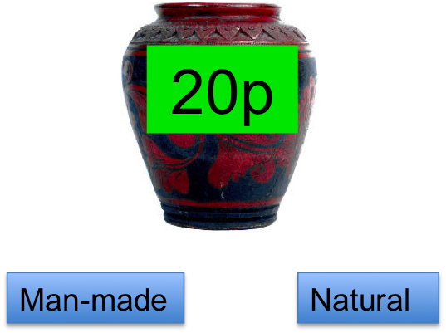

**OR**

3) If there is a possibility of being rewarded, you will only get the reward if you respond very quickly. If you are too slow to respond, the computer will tell you:

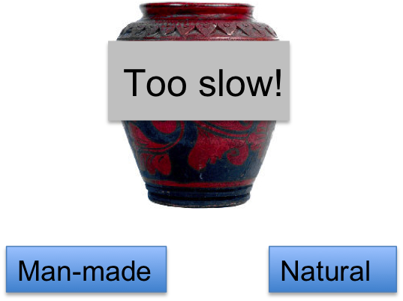

If there is no reward available, you still have to respond within two seconds.

**NOTE:** If your accuracy for deciding if an item is man-made or natural falls too low, you will not be given the money you win on the task

4) After a few trials, you will begin to work out that for one category there is a very high chance of being rewarded, and for another there is a very low chance of being rewarded. By the end of this phase, you should definitely know which of the categories is most likely to get rewarded.

Don’t forget that you still have to respond *accurately* even if you think there is no reward available. If your overall accuracy falls below a certain threshold, you will NOT receive the extra money that you win on the task!

**THE MONEY YOU WIN ON THE TASK WILL AFFECT HOW MUCH MONEY YOU TAKE HOME AT THE END OF SESSION 2.**